**LINUX TASK-1**

1Q: Create user with name Techie and provide sudo access to user.

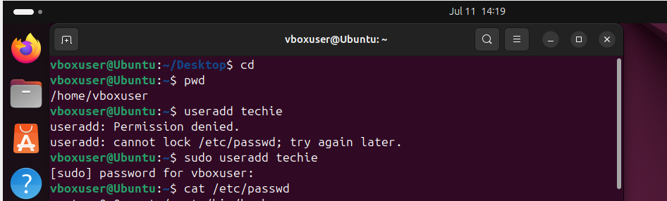



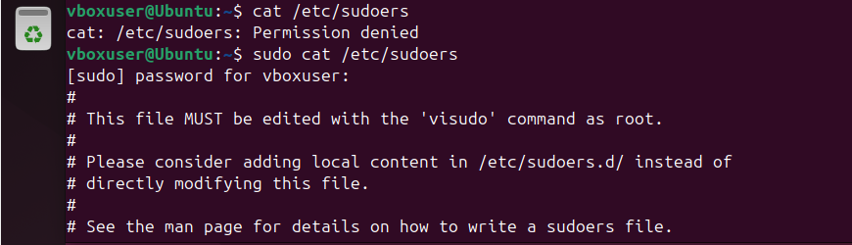



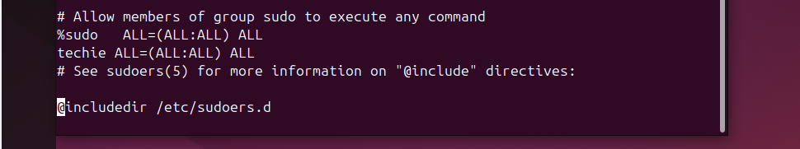

Add all acess to techie user as above by pressing I (its allow you to write here)

Switch to techie user

Su techie

Or

Sudo su techie

Because sudo is super user which has extra priviledges

Without adding sudo before the command it runs only for root user.

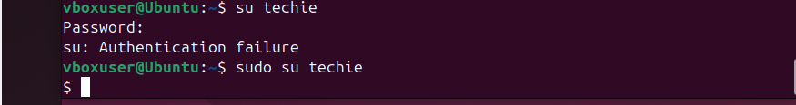

Now we are into the techie user by switching user command .

To check the accesses of techie user we need check command

For ex: apt install git

Then it gives the error

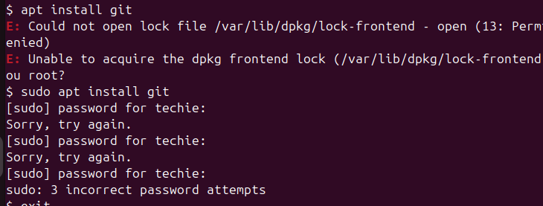

Here it is asking password for new user techie but saying incorrect password. Why because I didn’t create a password or techie user. So now I need to creat a password for techie user. For this I need switch to root user and give new password for techie user.

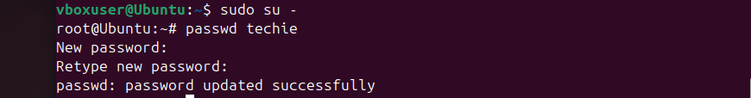

Again switch to techie user



Now you are in techie user. Here you try the example of access of any command

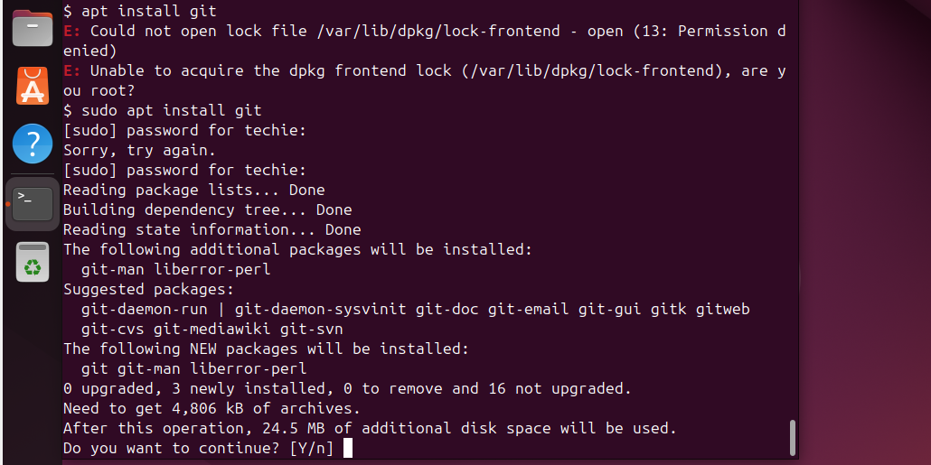

Press N because I don’t ‘want to install

2Q: Navigate to the home directory.

Enter pwd command to know the present working directory

And enter command cd .. to go to home directory

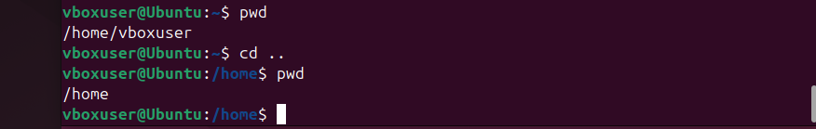

Now I am in home directory as above.

But to go to user level home directory that is ‘vboxuser’ it’s a user name for that

3) Create a new directory.

To create a new directory first check the present location by entering pwd

Enter command mkdir altaf_amjad



Then enter ls to check whether it is created or not



4. List the contents of a directory.

. first be in user level and check you have created directory’s or not by using command ls. Suppose I you have directory abdul_mohammed then enter command

.Then enter command ll abdul_mohammed

.It will display you all the files and contents of thie directory

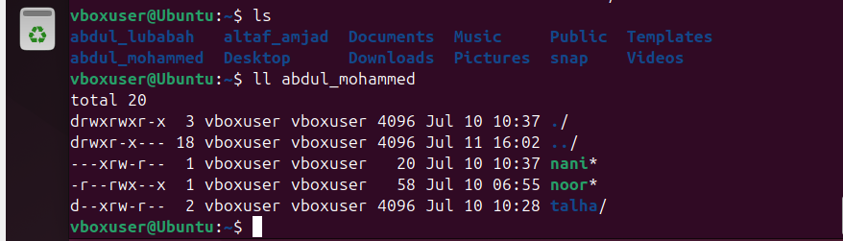

5. Change the current directory.

cd directory name



6. Create a new empty file.

Touch filename



7. View the contents of a file.



you should have content in the file or this irst write some contents. Command is vi man and save it

8. Copy a file to another location.

cp –r filename location

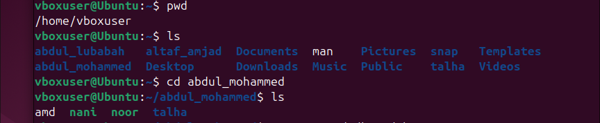





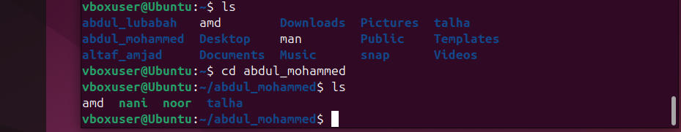

Like in the above the copy to the another location and remain in the same location also.

9. irst go to any directory which is consisting of files and take one file ex: rehan and move to another directory or location. For this enter command

mv filename pathlocation

mv rehan /home/vboxuser/altaf_amjad

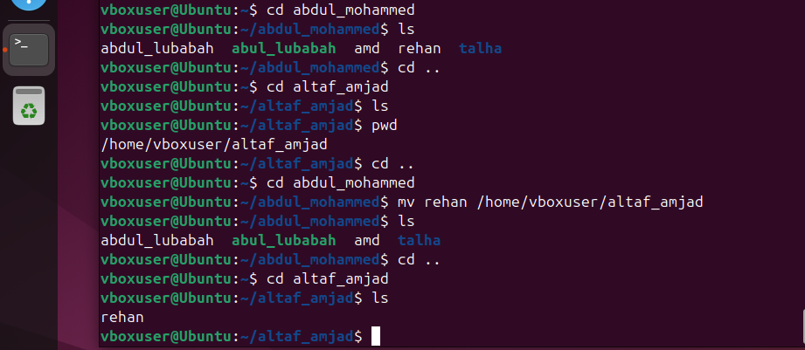

10. Rename a file.

Command is

mv filename givenewfilename

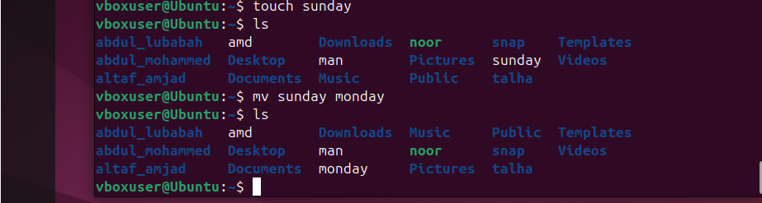

11. Delete a file.

rm –rf filename

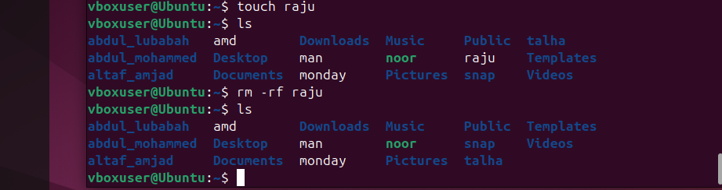

12. Grant or revoke permissions on a file or directory.

. to revoke or grant a permission we need see first the existing permissions file (amd 664) or directory. to grant or revoke permissions for this file command is

Chmod 776 filename or directoryname

Here the user has existing permission 664 means Read write, Read write,Read that is calculated based on the below concept.

Read = 4

Write = 2

Execute = 1

And now we have changed the permission like Read write Execute, Read write Execute, Read Write

That is command

Chmod 776 amd

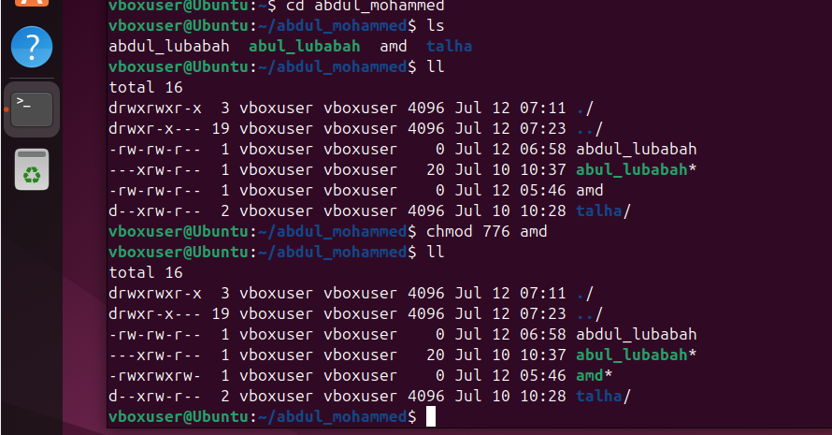

13. View the current date and time.

Command is

date



14. Check the system uptime.

Command is

uptime

what is uptime, It tells you how long your system has been ON without restarting or shutting down.



15. View the running processes.

Command is

Ps –ef

This command help us to get the list of running processes/services. Which running in my virtual machine.

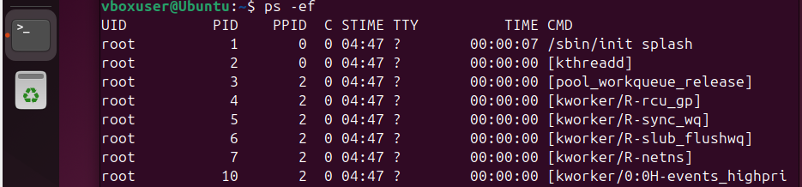

Continue o above

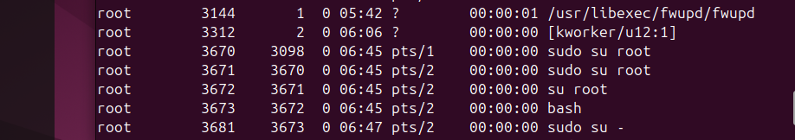

Continue…



Other Commands is for my test cases.

Top

Here it displays the details all the running processes and their usage. Similarly task manager of our windows of pc.

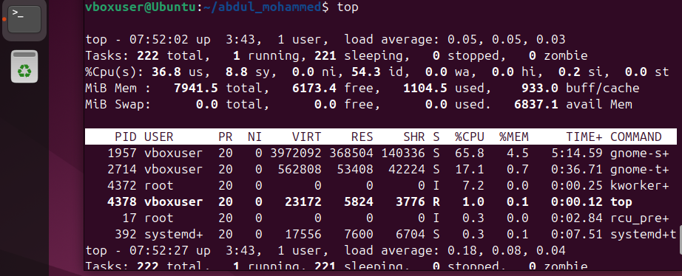

The command ps shows the current shell processes

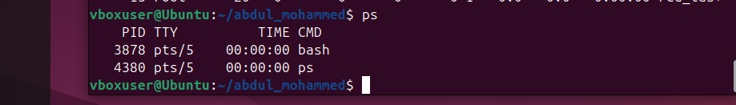

Testing scenario

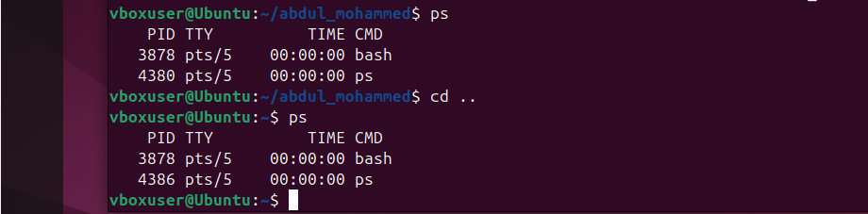

16. Kill a running process.

Command is

Kill

Or kill -9 procee ID

Kill -9 3878



Or



\*\*\***Note**\*\* But this Kill command is not recommended use ‘systemctl end stop nginx’ to stop a particular process like nginx process.

17. Install a package using the package manager (e.g., apt or yum).

The command is apt install nginx

If getting error then command is

Sudo apt install nginx

Here the package/process is git, nginx an you can get process by seeing processes.

apt is a package manager

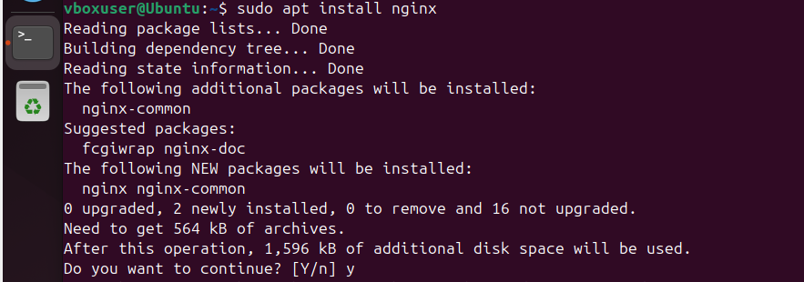

After installation of package

Start the package by suing command

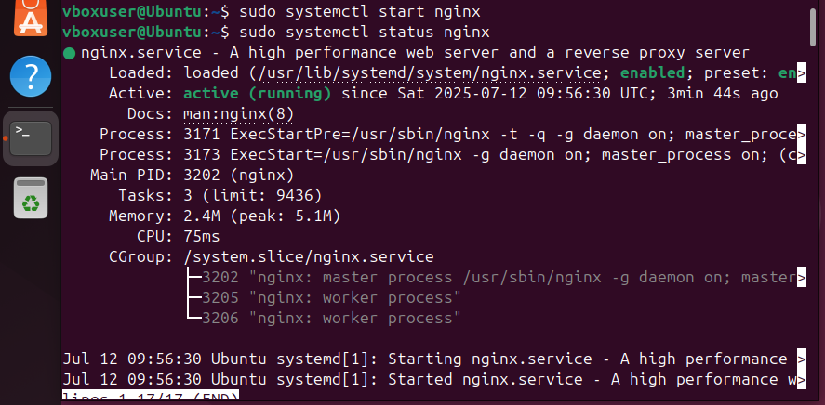

18. Update the system packages

To update the packages the command is

Sudo apt upate

First install , start, status upate

(Doubt : but here I want to or scenario new version upate of any installed package or any install package I want to give command as sudo apt update git or nginx or upated version of this or existing - )

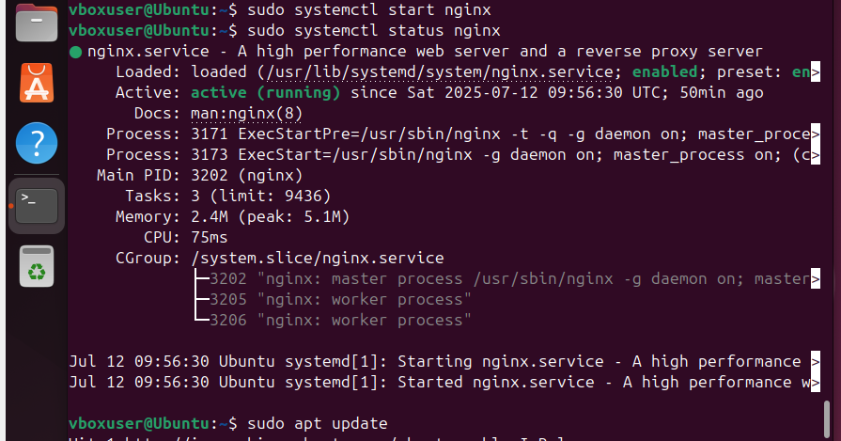

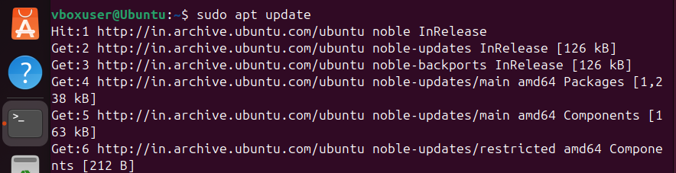

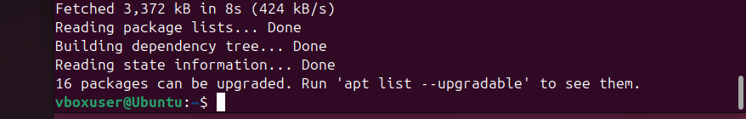

19. Create a symbolic link

Command is

ln -s (existing file name or directory path) > (link name)



Now give symbolic link to a fle name nfile2 according to it’s continuous path.



It’s shows in the ll



A symbolic link is a shortcut that points to another **file or directory** using its **path**.

20. Search for files using the find command.

Find / -name sudoers(or any file name or directory name

Ex: find / -name fold1 (it’s a created directory)

It will show the path in the bottom.

Ex: find / -name fold1a (it’s a created sub directory)

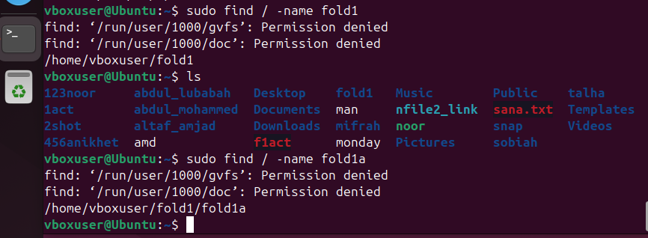

21. Compress and decompress files using tar.

. create a directory command mkdir file name (noor_tar1)

Then create files under the directory ex: a, b , c, d, e, f, g

Command touch a b c d e f g (a... is file names)

You can create number of files at one time

Now compress files command is

tar cvf give file name give directory name

Ex: tar cvf noorzip noor_tar1

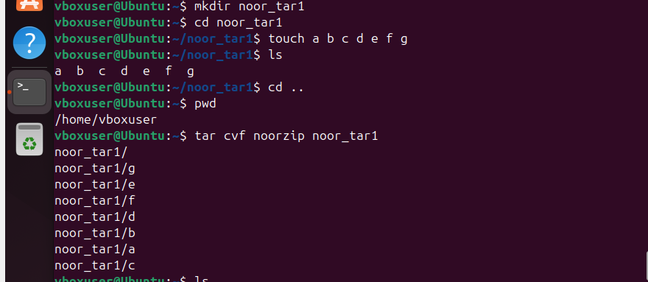

Continue

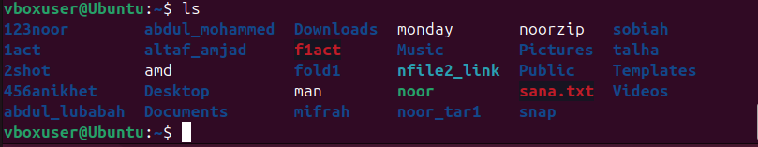

CVF = compress verbose file

Now decompress (extract) the file which is already compresse and given the new name i.e., noorzip)

Tar xvf noorzip

Xvf = extract verbose file

Ex: suppose you are compressed the file noor_tar1 and given name to compressed file as noorzip . what happen here the files of noor_tar1 has compressed and kept the noor_tar1 as well as noorzip file which allthe files.

Suppose now if you are deleting main directory noor_tar1

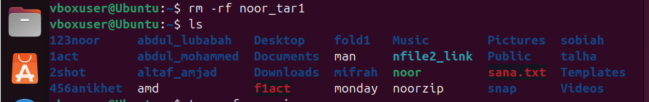

And now extract the noorzip. It will extract the file and shows the deleted file noor_tar1

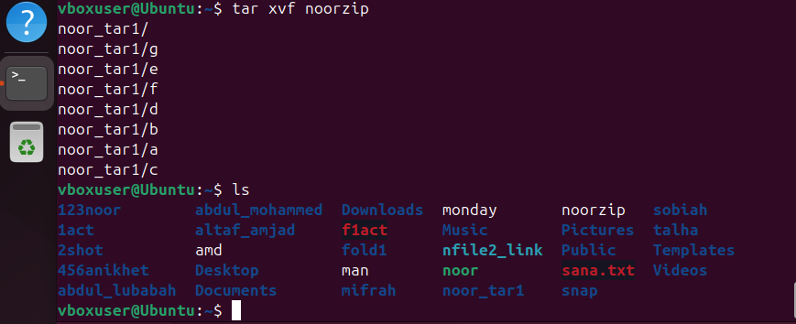

22. Monitor system resources with top or htop.

Top command use to see the processes of usage which are running the vm

Htop command is not executing . usage of htop command is an interactive, real system-monitoring tool – like an upgraded, colourful version of the top command.

Command is

Top

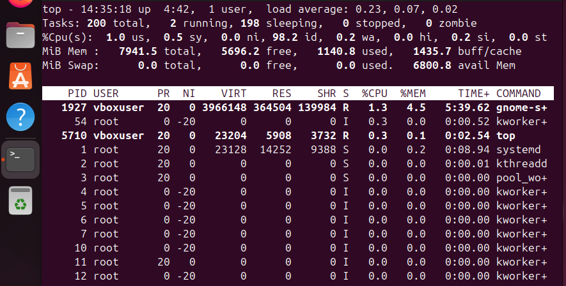

23) .

Create and manage user groups.

To create a group command is



To display all groups command is



Getent group

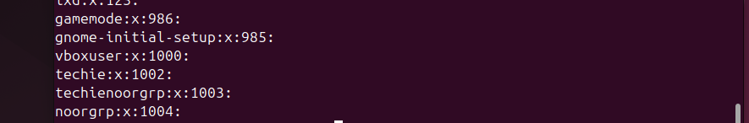

To display a particular group

Getent group groupname

Here group also command parameter jfi



Rename a Group

Ex: I have noorgrp as a group name

sudo groupmod -n newname oldname



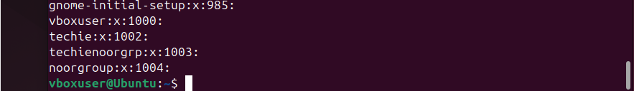

See above noorgrp has changed noorgroup

Display user list cat /etc/passwd

Techie is user

Now assign user to group (do reaserch later)

sudo usermod -aG groupname username

Remove a User from a Group

sudo gpasswd -d username groupname

Delete a Group

sudo groupdel groupname

Manage Group Membership Interactively

sudo nano /etc/group

format

make a file

groupname:x:GID:user1,user2

sudo chown :groupname /path/to/directory

sudo chmod 770 /path/to/directory

research on below things

• Add multiple users to a group

• Create a group if it doesn’t exist

• Audit group memberships

25

This will **continuously display new lines** added to the file (as they appear). Useful for live monitoring of system logs, app logs, etc.

Find log file first command is

ls /var/log

here var is a system directory of os and log also directory in a os and syslog is a file in the respeted path.

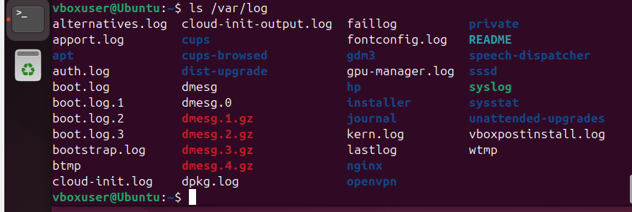

2) Ex: here is a file name is syslog. To monitor the log file by tail as below

Tail –f /var/log/syslog

To **monitor log files in real-time** using the tail command, use the -f (follow) option

This will **continuously display new lines** added to the file (as they appear). Useful for live monitoring of system logs, app logs, etc.



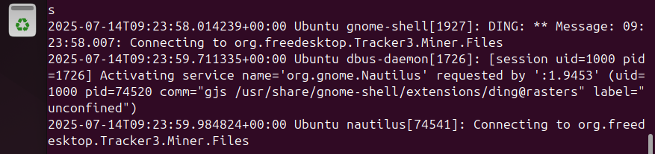

The files continuously monitor by going up line in above scree and updated files also add in this.

Monitor log files using grep

To **monitor log files using grep**, you typically combine it with commands like tail or less. grep is used to **search for specific patterns** (like error messages, IPs, or usernames) inside log files.

Search for a pattern in a log file

grep "pattern" /var/log/syslog

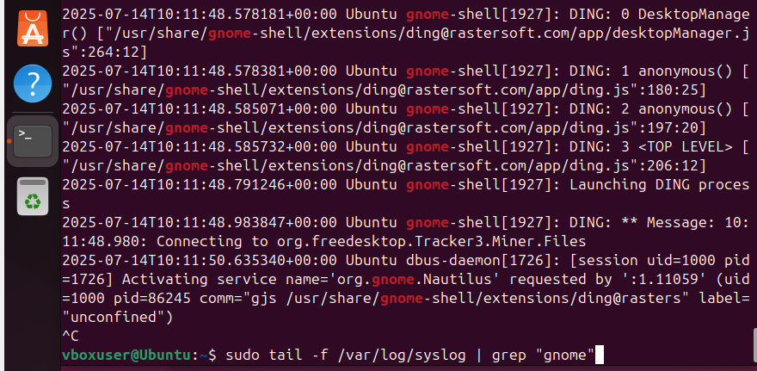

Like the above pattern “gnome” will highlighted by using the above command once you enter.

26) Set up a web server (e.g., Apache or Nginx).

Set up a web server Apache

**What is Apache?**

**Apache** (full name: **Apache HTTP Server**) is a **free and open-source web server** software developed and maintained by the **Apache Software Foundation**.

It is one of the **oldest and most popular** web servers in the world — powering millions of websites and applications.

Install , start, status, update, stop etc.,

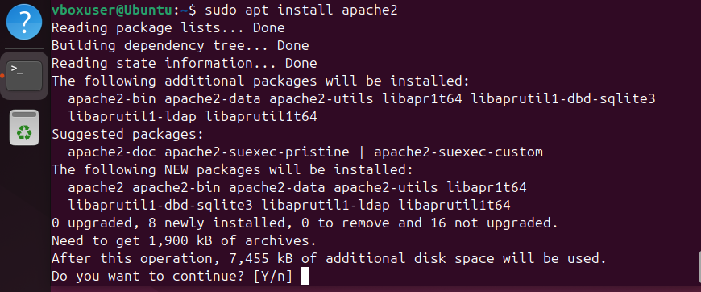

Press y and enter

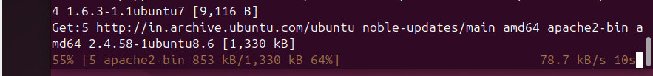

Has installed completely

27) Configure and secure a MySQL Database.

**MySQL Server** is the **software** that runs the **MySQL database system** on your machine or server.

There is **no separate package** called just "MySQL Database" — the **MySQL Server** is the **software** that lets you **create and manage databases**.

Command is

Sudo apt install mysql-server

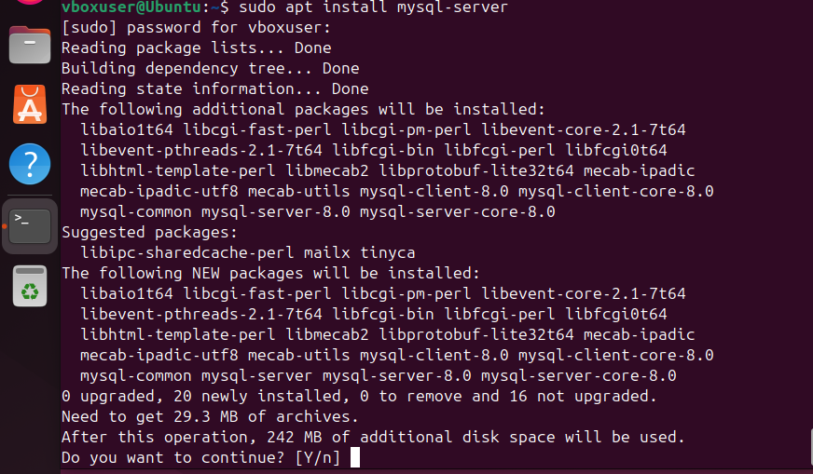

Press Y if want to install.

28) Set up a Application Server (e.g.,ApacheTomcat)

**Apache Tomcat** is an **open-source application server** developed by the **Apache Software Foundation**. It is used to **run Java-based web applications**.

Tomcat provides a **Java Servlet container** and **JSP (JavaServer Pages) engine**, allowing you to:

* Run Java Servlets
* Serve JSP files
* Deploy .war (Web Application Archive) files
* Host dynamic web content built in Java

**JDK** stands for **Java Development Kit**.

It is a **software development kit (SDK)** provided by Oracle (and others like OpenJDK) that is used to **develop and run Java applications**.

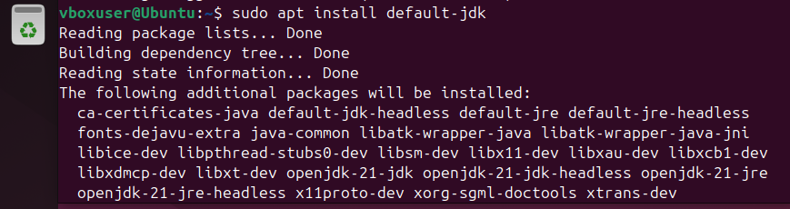

30. Print specific columns from a delimited file

Frist create a file which is consisting of delimeters

A **delimiter** is a **character or symbol** used to **separate data fields** in a text file.

It tells the system where **one column ends and the next begins**.

### Common Delimiters

| **Delimiter** | **Used In** | **Description** |
| --- | --- | --- |
| , | CSV files | Comma-separated values |
| \t | TSV files | Tab-separated values |
| ` | ` | Custom logs |
| : | System files | Like /etc/passwd |
| ; | European CSV files | Semicolon-delimited |

Here in my example I created a delimited file by using , as Delimeter.

Touch delifile1 (delifile1 is a filename)

In that I gave data which is consisting of **,** coma delimiter like example

To edit/write in the file I used here nano command .

To edit/write in the file we have 3 editors like VI, VIM, NANO

So To edit/write in the file I used here nano command .

nano delifile1

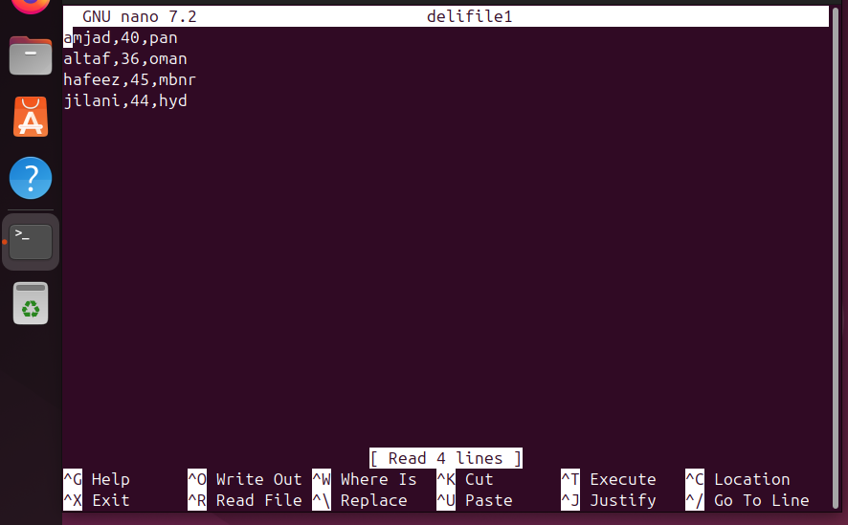

enter

here give data with coma , using and press ctrl+o to save then press enter then ctrl+x to exit.



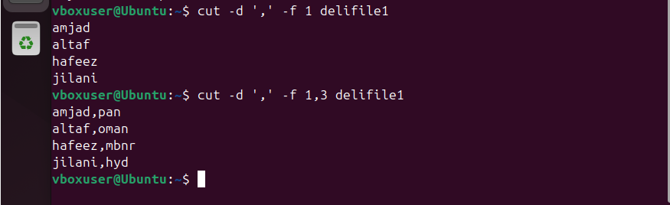

### Example with cut

cut -d ',' -f 2 data.csv

Here:

* -d ',' tells cut to use a **comma** as the delimiter.
* -f 2 means "print the **second column**".

31) Filter and print lines based on a specific pattern or condition.

31file is filename



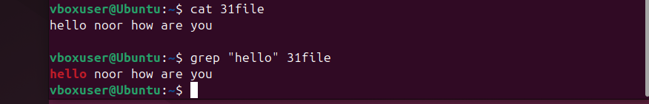



It will give number lines which is consisting of “hello” word in a particular file 31file

32) Calculate and print the average, sum, or other statistics of a column

### ****Calculate the Sum (excluding header)****

Command is

awk -F',' 'NR>1 {sum += $2} END {print "Sum =", sum}' data.txt

**Explanation:**

* -F',' sets comma as the delimiter.
* NR>1 skips the header.
* $2 is the second column (Score).
* sum += $2 adds each value to sum.
* END { print ... } prints the final result.
* • NR > 1 means: **"Only process lines after the first line."**
* • Since the **first line** (NR == 1) is usually the **header** (like Name,Score), this condition **skips it**.

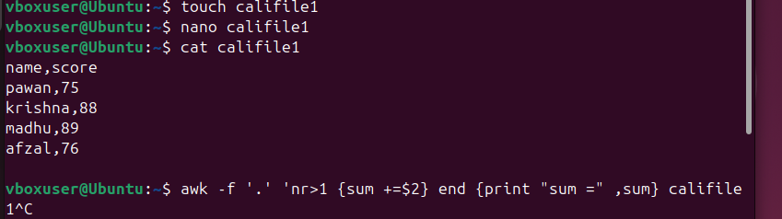

Check the formal is not executing why?

Ls /var/log

24) Set up SSH password less authentication. 25) Monitor log files using tail or grep. 26) Set up a web server (e.g., Apache or Nginx). 27) Configure and secure a MySQL Database. 28) Set up a Application Server (e.g.,Apache Tomcat) 29) create a service file for Apache Tomcat.(Should execute by using systemtctl command) 30) Print specific columns from a delimited file. 31) Filter and print lines based on a specific pattern or condition. 32) Calculate and print the average, sum, or other statistics of a column. 33) Perform string manipulation, such as extracting substrings or changing case. 34) Count the occurrences of a specific pattern in a file. 35) Sort lines based on a specific field or column. 36) Merge multiple files based on a common field or column. 37) Substitute text in a file using search and replace. 38) Delete specific lines based on a pattern or line number. 39) Append or insert text before or after a specific pattern or line. 40) Print only specific lines from a file. 41) Copy file from linux to windows machine 42) 5 use cases for AWK and 5 use cases for sed

Swith to root user

Check the sudoers file

Find the file “sudoers’ location

For this enter command

Find / -name sudoers

Here it gives all the paths of files of our virtual machines

From this files get the /etc/sudoers

Enter commans for details of sudoers

Cat /etc/sudoers

Goto previledge specification

Vi /etc/sudoers